Name: Rahul Kumar Rajak

**Case Study 14:**

|  |  |
| --- | --- |
|  | For the fields with data elements, create a domain first and then create the data element and use it in table.  1. Create Table maintenance generator for both the tables with :  Authorization group = &NC&  Function group = (Name of the table)  2. Open ZSTUD_DETAILS in SM30, you’ll see the header for Address is replaced by ‘+’ sign. Make correction in the header by replacing the ‘+’ sign by ‘Address’  3. Do the similar corrections in SM30 for   ZSUBJ_DETAILS |

**Solution:**

**TMG for 1ST TABLE ZRSUBJ_DETAILS.**

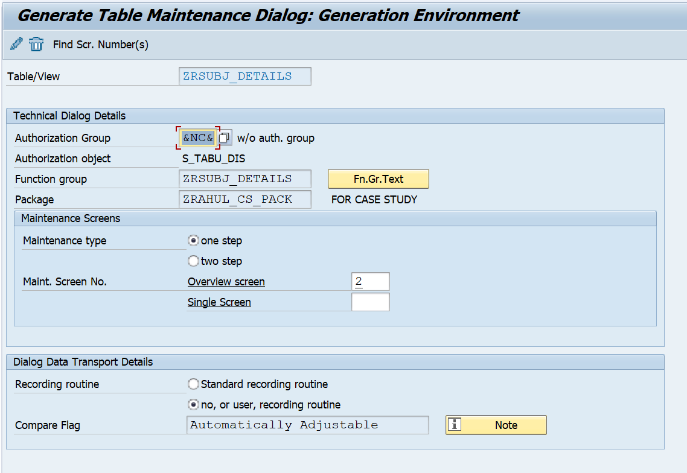

**SM30 for 1st table having + SIGN.**

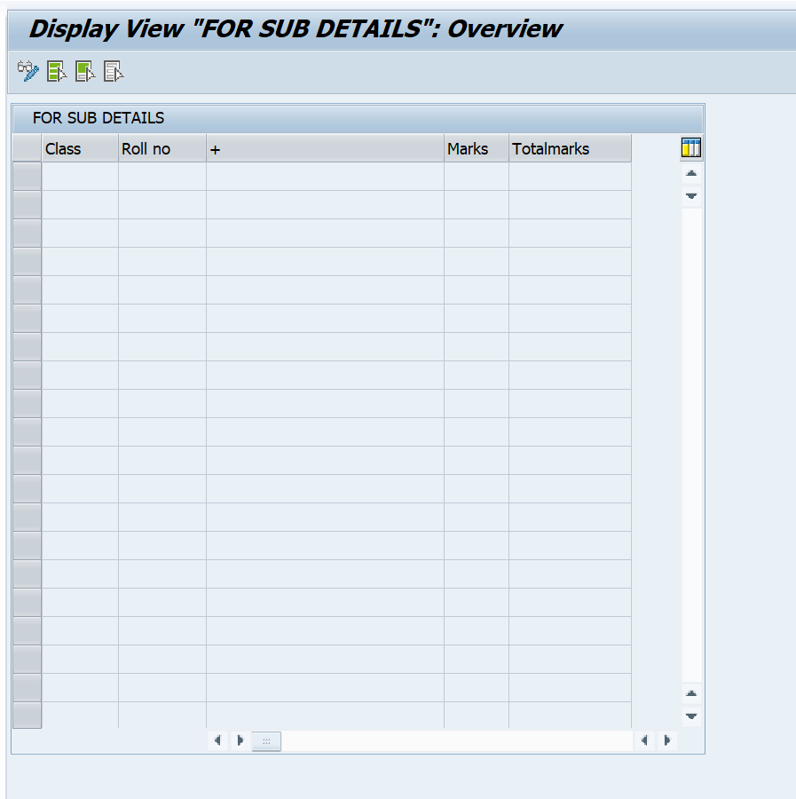

**SM30 for 1st having header SUBJECT.**

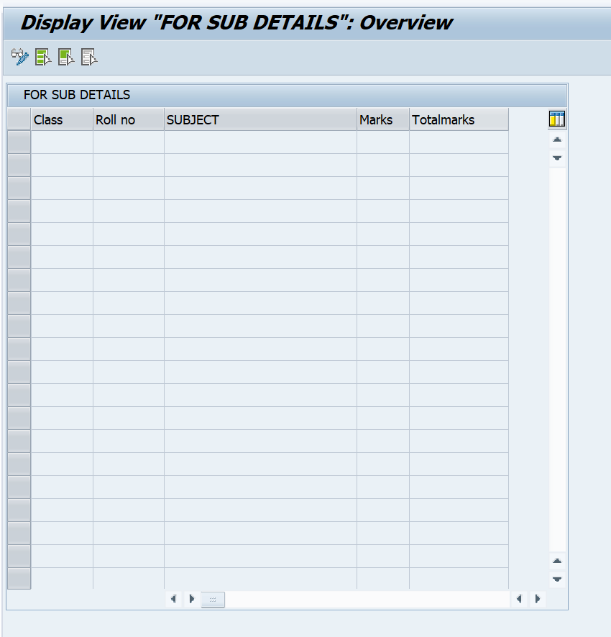

**TMG for 2nd table ZRSTUD_DETAILS.**

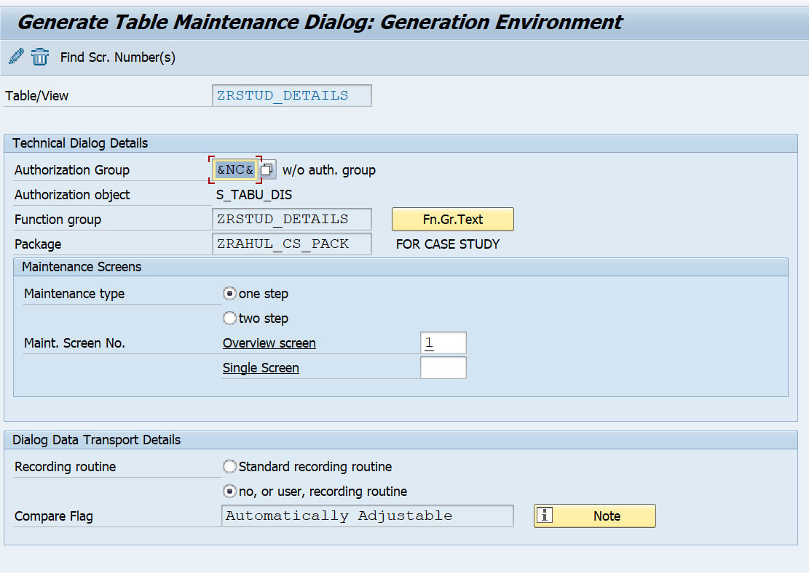

**SM30 FOR 2ND table having + sign.**

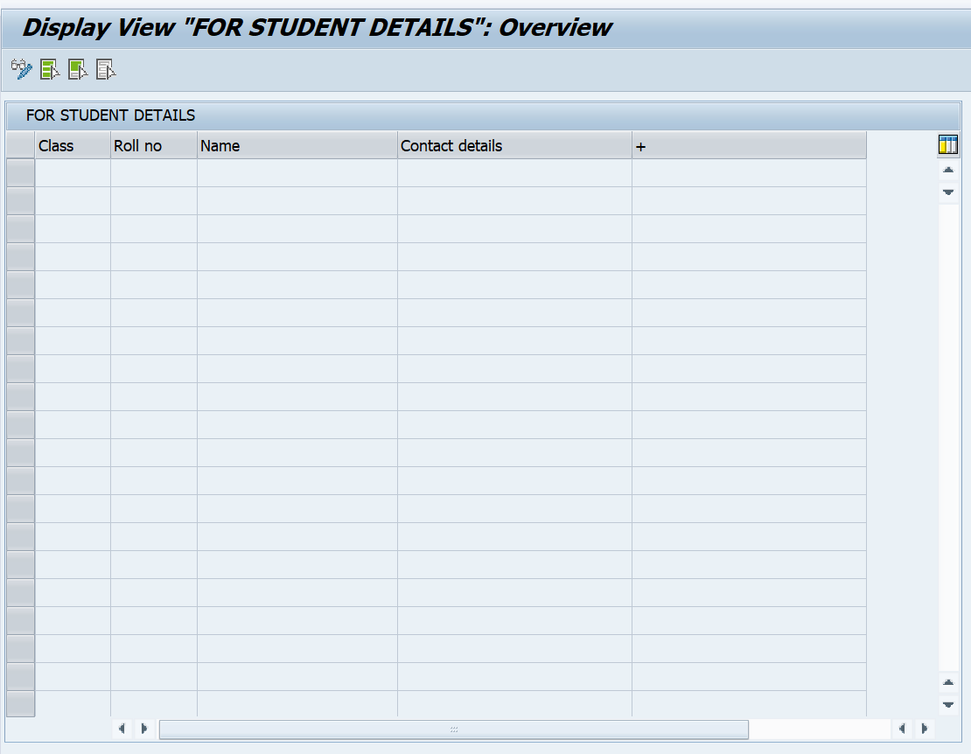

**SM30 FOR 2ND table having header a ADDRESS.**

